**EC2 INSTANCE**

**STEP 1:**

Select the EC2 instance from the Services.

**STEP 2:**

Click on the Launch Instance.

**STEP 3:**

Name the instance and select AMI.

**STEP 4:**

Create New Key Pair and name the Key pair. Then select private key pair as RSA (by default) and select .ppk (PuTTY) as private key file format.

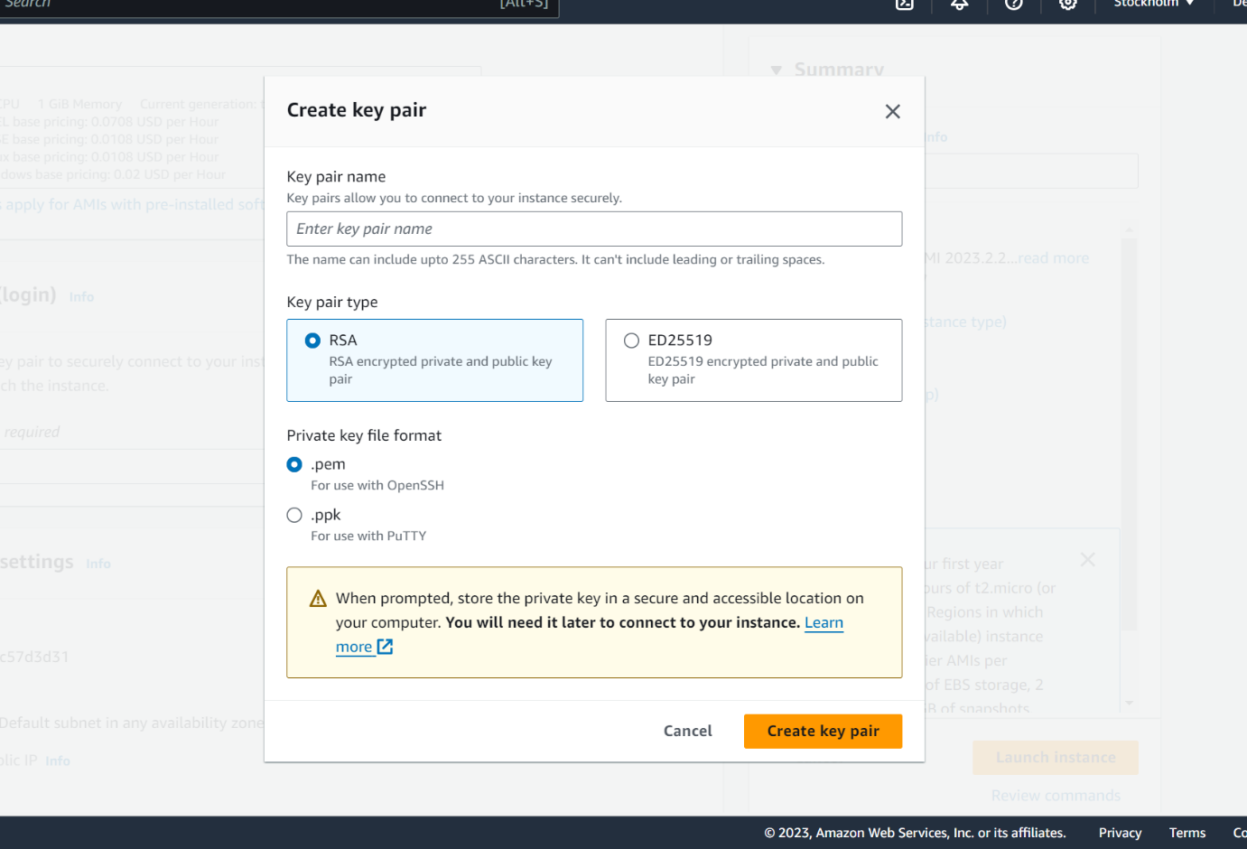

**STEP 5:**

Then the instance is successfully completed. After that click on view instances and see the check status of the instance.

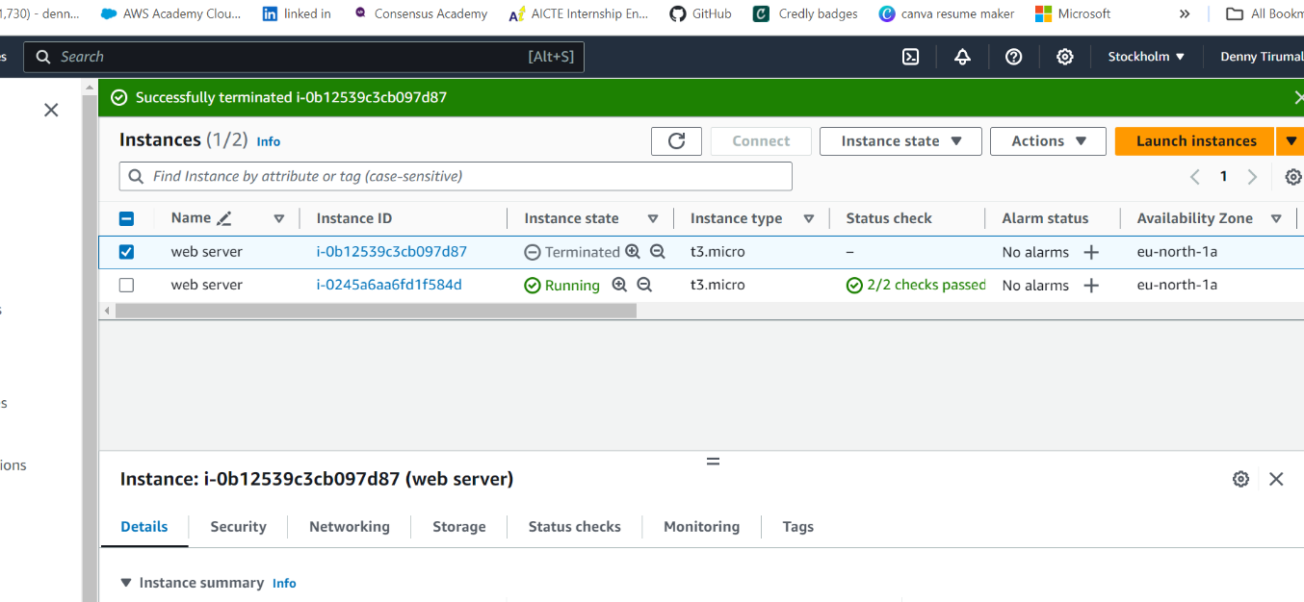

**STEP 6:**

By selecting instance click on the connect option then we will see the following information copy the address as shown in image.

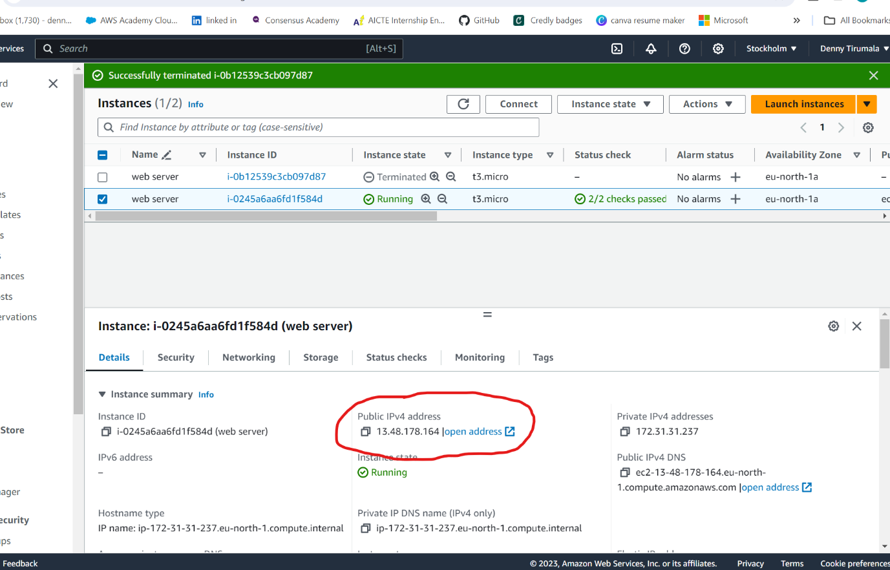

**STEP 7:**

Connect to the Linux instance from the window client operating system using putty.

Follow the below steps to connect to the Linux instance from the Windows client operating system using putty:

**STEP 8:**

Install and open puttygen application and click on the load.

Browse and select the keypair file i.e. .pem file and click on the save private key and a .ppk file will be saved.

**STEP 9:**

Open putty application and paste the host address copied from the connect to instance tab, which we have previously copied.

**STEP 10:**

Now click on SSH and click on auth tab and browse for the .ppk file which we have saved earlier and then click on open.

**STEP 11:**

You will be prompted to click on accept, click accept.

**STEP 12:**

Now the putty terminal will be open where we can access the EC2 install that is running on AWS servers.